ADAP Unit

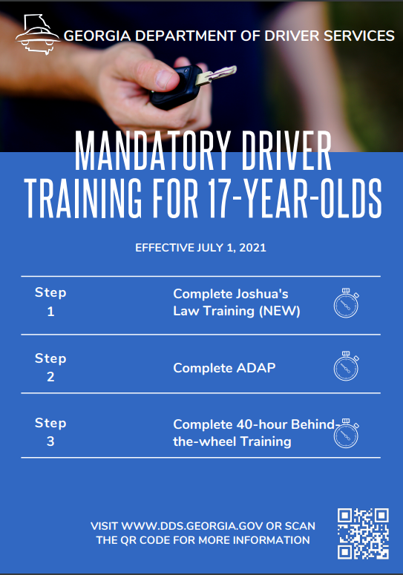

Classwork: Day 1 : December 1, 2024

1. **Student DDS account setup**
2. **Ch.1 ADAP one pager**

-

|  |  |  |
| --- | --- | --- |
| **Criteria: Title/heading for all content should be included in your one pager** | **Points** | **Point Earned** |
| **Name & Title** | **20** |  |
| **TADRA-what it stands for** | **10** |  |
| **TADRA-the purpose** | **10** |  |
| **Graduated Driver’s License Process-the steps & a brief description of each** | **30** |  |
| **3 Restrictions of Class D license** | **15** |  |
| **Drinking Alcohol**  **-legal age to consume**  **-BAC defined**  **-BAC level that is considered DUI** | **15** |  |
| **2 Images relevant to the information** | **20** |  |
| **Total** | **120** |  |

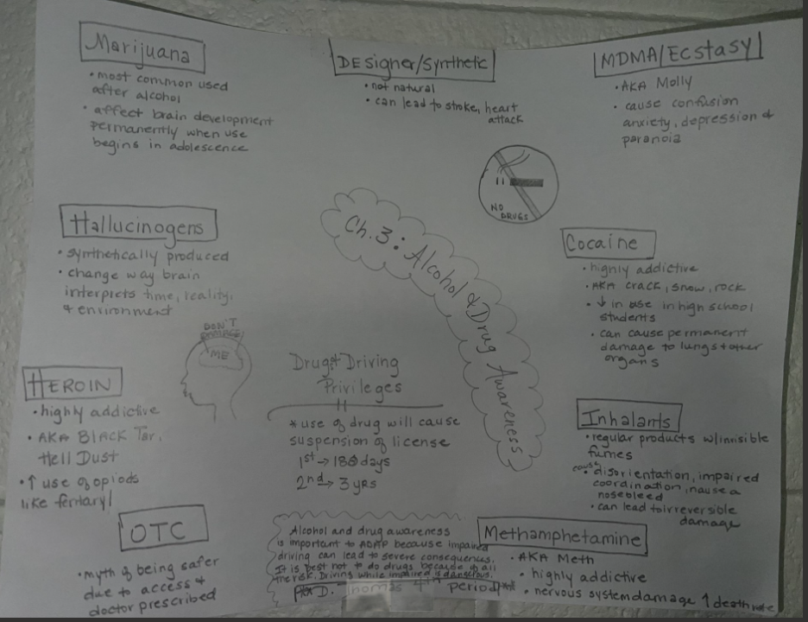

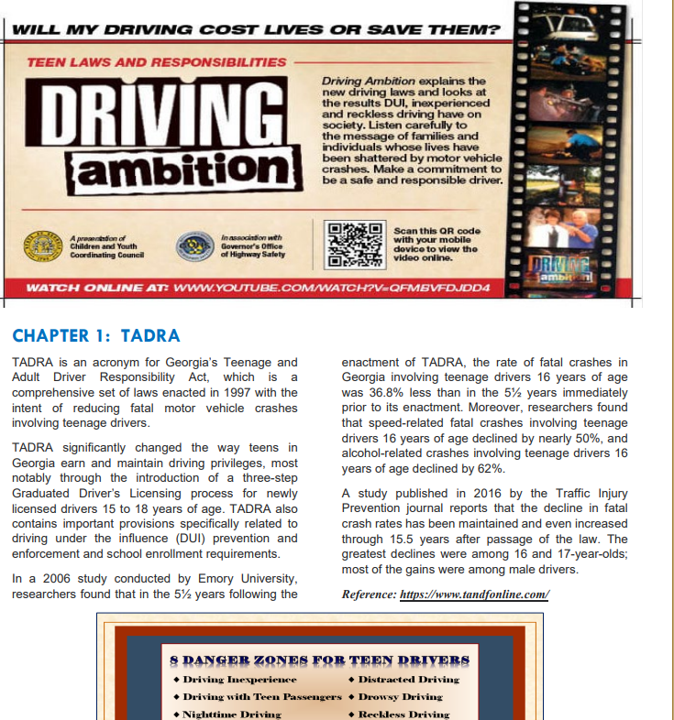

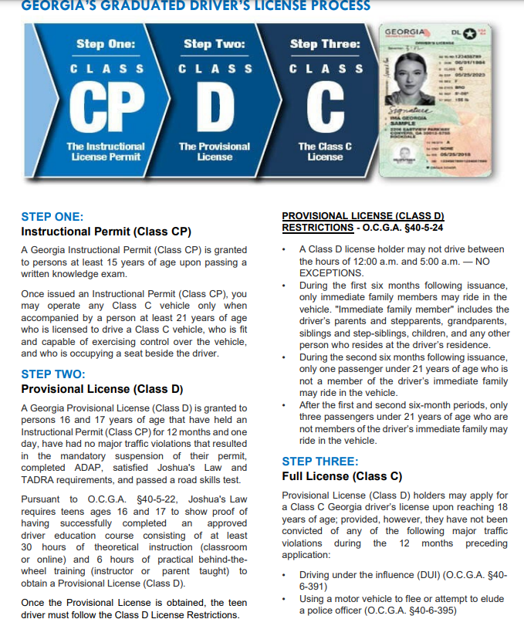

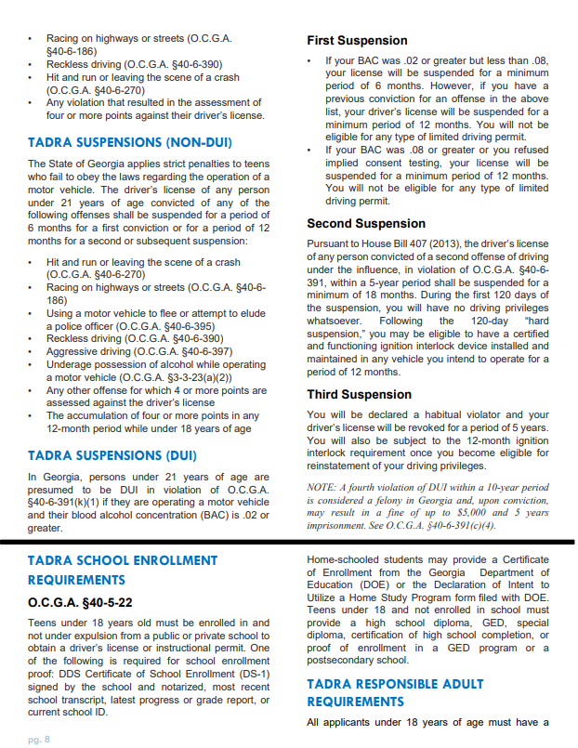

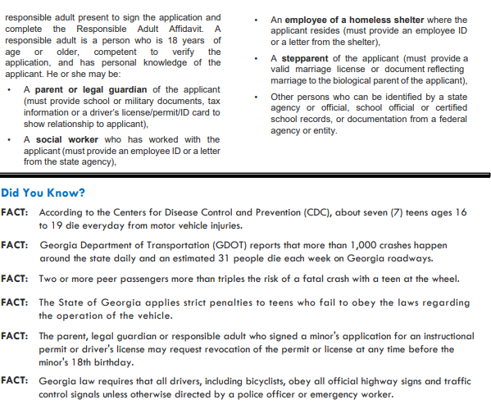

Day 2: December 2

Warmup : Dec 2

Copy what you see below:

**ADAP Learning Targets**

1.I can define what TADRA represents

2.I can explain the purpose of TADRA

3. I can list the requirements for students drivers

4. What do the following stand for:

**a.TADRA**

**b.ADAP**

**c.OTC**

**d.DUI**

Classwork: Day 2: December 2, 2024

**Classwork:**

**1.Close Read & Class Discussion**

|  |  |
| --- | --- |
| **Criteria** | **Possible Points** |
| Chapter Title | **10 points** |
| 9 subheadings (highlighted & or underlined)-bold black | **20 points** |
| 5-7-word overview/importance of the specific safety practice or law (basically, do this for the subheadings from above) | **20 points** |
| 2 images relevant to chapter | **20pts** |
| 3 sentence summary of chapter | **20 pts** |
| Name & class period at bottom | **10 pts** |
| **Total Possible** | **100pts** |

1. **Ch.2 One pager**

**Create One pager on ch.2 of ADAP Manual: Traffic Laws & Safe Driving**

**\*Extra credit for creating this chart and completing your own checklist of your one pager making sure you have each requirement* (if you check is incorrect then no credit will be earned) \*\***

**Day 3: December 3, 2024**

Do Now: December 3

1. List three things you know about ADAP

Classwork

Day 3: December 3, 2024

1. **Chapter 3 Partner Expert Panel video Or PowerPoint presentation with voice recording to present the information: follow the rubric based on assigned topic**

|  |  |  |
| --- | --- | --- |
| **Chapter 3 ADAP Information** | **Possible Points** | **Points Earned** |
| Name of Drug | **10** |  |
| 3-4 other names and/or examples | **10** |  |
| Standard cost per measurement | **10** |  |
| Who typically use the drug and those that are at highest risk | **10** |  |
| At least 6 health effects (3 long term & 3 short term) | **20** |  |
| How does your drug impact your ability to drive (be specific)?? | **10** |  |
| Relevant images with each slide | **30** |  |
| **Total** | **100** |  |

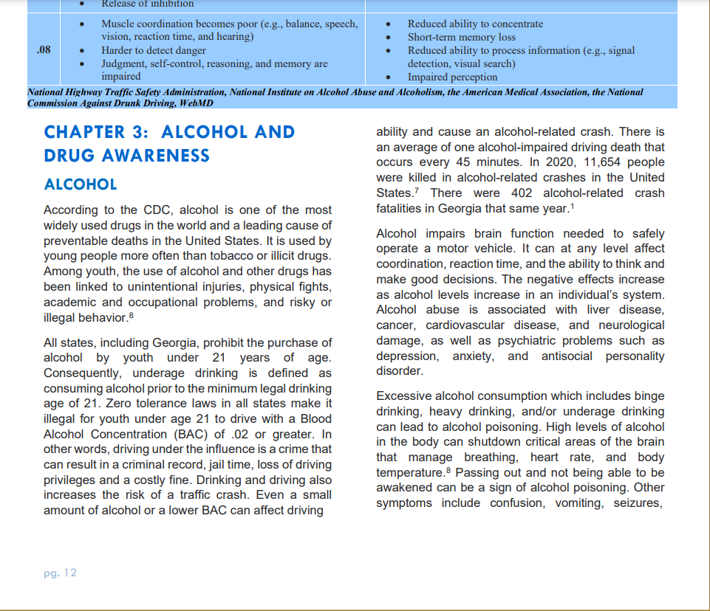

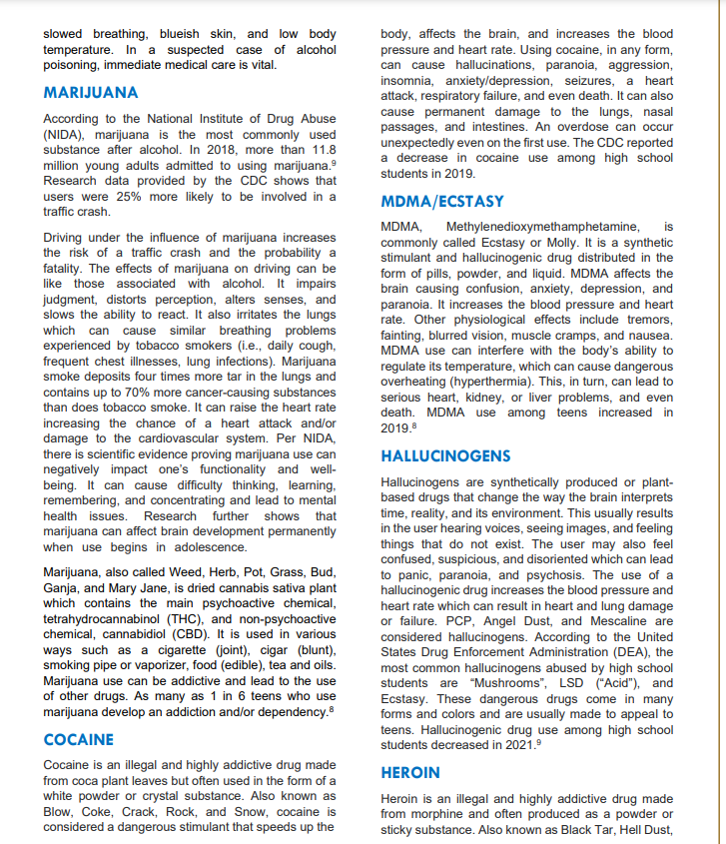

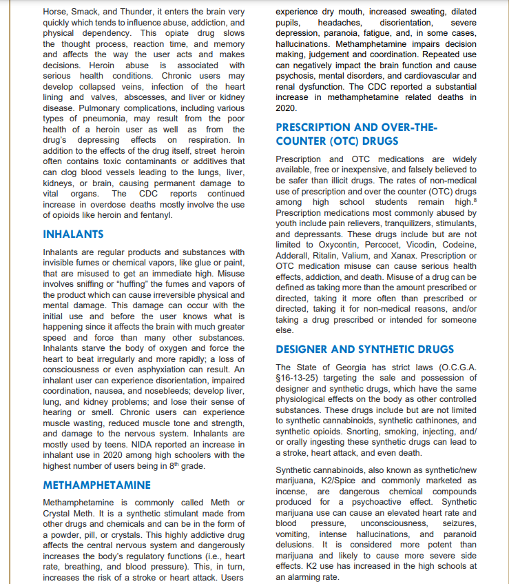

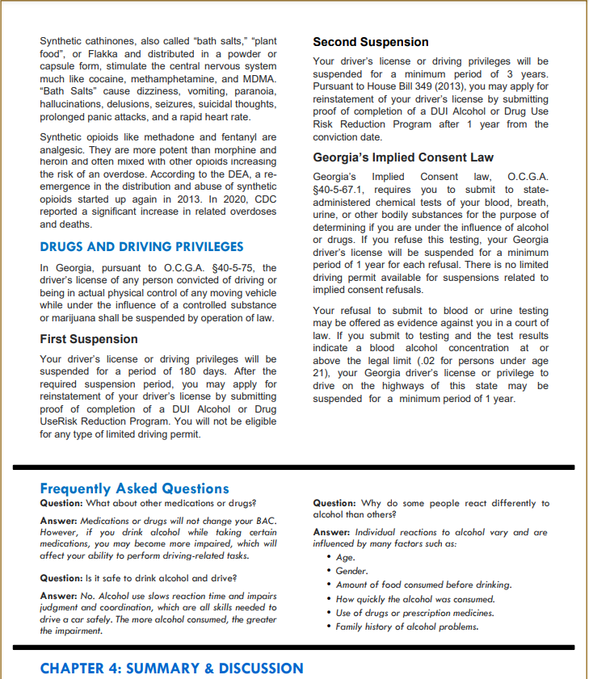

**Day 4: December 4, 2024**

Classwork: December 4

Write Question & answer OR restate question in your answer for study guide

**ADAP Study Guide**

**Make sure you write the question and answer, provide headings for each questions, or restate the questions with the answers for FULL CREDIT.**

*TADRA and Traffic Laws and Safe Driving*

1. What does the acronym TADRA represent?
2. What is the classification for Provisional license?
3. List 2 requirements for those 16 years of age to obtain a Provisional License?
4. With an Instructional Permit (Class CP) when are you able to operate a Class C vehicle?
5. What are the hours in which a holder of a Class D license unable to drive?
6. With a Provisional License (Class D) who can ride with you during the first 6 months?
7. What are the consequences for refusing a drug/alcohol test?
8. (Fill in the blank) Any driver under age 18 who holds a Class D license or a learner’s permit is prohibited from using ____________________.
9. What is the leading cause of teen in the U.S.?
10. How much does the risk of a fatal crash increase with a teen driver having two or more peer passengers?
11. What is the most widely used drug in the world?
12. List 4 long term effects of alcohol misuse.
13. Fill in blank. BAC stands for _________ ___________ _____________
14. Fill in blank. It is illegal for those 21 or younger to drive with a BAC of ________ or greater.
15. List 4 drugs and 1 effect they have on the body (1 effect for each drug)
16. Why is it not safe to drink and drive?

Day 5: December 5

Classwork:

1. Makeups (complete any assignment you have not done for the week using the resources provided)
2. Class Review